Lab Manual # 06

Student Name: Muhammad Touseef

DATE: 28TH_OCT _2023

**CMS: 460700**

LAB TASK 6:

TASK1:

#include<iostream>

using namespace std;

int main(){

int num1 =0;

int num2 =1;

int n;

int res;

cout<<"enter the number of terms in fibonacci sequence";

cin>>n;

for(int i=1;i<=n;i++){

if (i<=1){

res=i;

}

else{

res=num1+num2;

num1=num2;

num2=res;

}

cout<<res;

}

return 0;

}

OUTPUT:

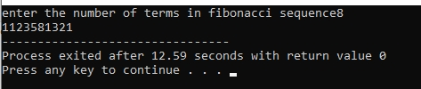

TASK 2:

#include<iostream>

using namespace std;

int main(){

int n;

cout<<"enter the number of rows";

cin>>n;

for(int i=1;i<=n;i++){

int coef=1;

for(int k=n-i;k>0;k--)

cout<<" ";

for(int j=1;j<=i;j++)

{

cout<<coef<<" ";

coef=coef*(i-j)/j;

}

cout<<endl;

}

return 0;

}

OUTPUT:

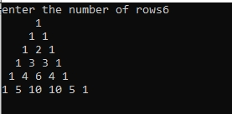

# 

HOMETASK 6:

TASK 1:

#include <iostream>

using namespace std;

int main() {

int prime_sum = 0;

for (int num = 1; num <= 50; ++num) {

// Check if the number is prime

bool is_prime = true;

for (int i = 2; i <= num / 2; ++i) {

if (num % i == 0) {

is_prime = false;

break;

} }

if (is_prime) {

prime_sum += num;

} }

cout << "Sum of prime numbers from 1 to 50: " << prime_sum << endl;

return 0;

}

OUTPUT:

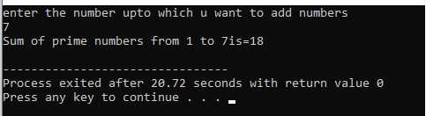

TASK 2:

#include<iostream>

using namespace std;

int main(){

int n;

cout<<"enter the given numbers of rows";

cin>>n;

for(int i=1;i<=n;i++)

{

for(int k=1; k<=i;k++)

cout<<k;

cout<<endl;

}

return 0;

}

OUTPUT:

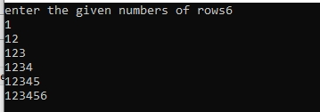

TASK 3:

#include <iostream>

using namespace std;

int main() {

int rows = 4;

int num = 2;

cout<<"1"<<endl;

for (int i = 1; i <= rows; i++) {

for (int j = 1; j <= i * 2; j++) {

cout << num << " ";

}

num += 2; // Increment by 2 for the next row

cout << endl;

}

return 0;

}

